**School of Computing, Engineering & Physical Sciences**

**MSc Masters<*Information Technology*>**

**Interim Report**

Analysis and comparison of data visualization software using Tableau and PowerBI for company marketing performance   
    
    
    
**by**   
 

***Irikannu Ifeoma Blessing***

***B01639940***

**Date of submission: *24/06/2024***

**Supervisor: Dr. Rebecca Redden**

**Moderator: Dr. Joanna Olszewska**



**DECLARATION OF ORIGINALITY**

I declare that this is an original study based on my own

work and that I have not submitted it for any other

course or degree.



Signature_______________________

## **Table of Content**

Table of Content 1

1.1 Introduction 1

1.2 Background 1

1.3 Problem Statement 2

1.4 Objective of the Study 3

1.5 Research Questions 3

1.6 Significance of the Study 3

Chapter 2 4

2.1 Literature Review 4

2.2 Definition of Business Intelligence 4

2.3 Introduction to Data Visualization 4

2.4 Principles and Practice of Data Visualization 5

2.5 Definition of Marketing 7

2.6 Impact of Data Visualization on Marketing Performance 8

Chapter 3 9

3.1 Methodology 9

3.2 Introduction 9

3.3 Research Design 9

3.4 Research Strategy 9

3.5 Dataset 10

3.6 Dashboard Design 11

3.7 Data Collection 13

3.8 Feature Evaluation and Comparative Analysis 14

4.0 Plan for Completion 15

Reference 17

**Table of Figures**

Figure 3.1 Dataset 11

Figure 3.2 Data Source Interface 12

Figure 3.3 Line Chart - Data View 13

Figure 3.4 Dashboard View 13

**List of Tables**

Table 4.1 Plan for Completion key steps and their expected duration 17

**Chapter 1**

# **1.1 Introduction**

## **1.2 Background**

Data visualisation is an important aspect of business intelligence that involves visualizing data using charts, graphs, and other visuals that allow for clear understanding and interpretation of the data. The process includes using graphs, charts and other visuals to present information in an informative manner (Piin and Nagalingam, 2023,p858). Data visualisation will allow stakeholders to recognize and analyze recurring patterns and trends in the organisation data, therefore using the dashboard to make informed decisions (Hamad *et al*., 2020,p38). Data Visualization provides an opportunity to present results from data analysis and allow users to interact with data and derive insights that can be used to improve business processes and performance (Jena, 2019,p20).

Data Visualization is an important component of Business Intelligence. Business Intelligence involves various activities, technology stacks and software which focus on helping organisations gather, store, analyse and visualise their business data to support continuous operational and strategic decision (Mariani *et al*., 2018,p3517). According to Mehanović and Durmic (2022,p2), Business intelligence processes involve the following steps; data collection, data storage, data preparation, data analysis, data visualisation and insight generation. Business Intelligence (BI) system combines database management, data analysis and data visualisation to provide an intricate framework to process, analyse and visualise organisation data (Chongwatpol, 2016,p1781).

Marketing Analytics involves the process of analysing marketing data and evaluating marketing activities to assess trends, opportunities and their impact on business growth and profitability. The process uses analytical software to store, analyse, visualise and monitor marketing key performance metrics (Branda *et al*. 2018). By tracking the marketing metrics and performance, businesses can optimise their spends, ad costs on marketing campaigns. Marketing analytics plays an important role in enhancing business performance (Lin, 2024).

Data has been leveraged in different ways to improve marketing performance. In the research of Luca *et al.* (2020), businesses are investing significantly in Data and BI technologies with the aim of improving the marketing performance allowing them to transform their business. With the help of data, Companies hope to dive deep into understanding the complex nature of their customers' behaviour by leveraging automated monitoring systems of social media data allowing for a more informed decision like personalised campaigns, targeted ads and streamlines marketing strategies. Often, businesses struggle to choose the right data analytics/visualisation software that would meet their needs and improve their decision making. Companies invest significantly in this software, hoping to get a better return on their investment. However, the wide range of available software in the market can be challenging and misleading.

This research focuses on comparing data visualisation software and their effectiveness in driving marketing performance. The outcome of this research will assist marketing firms and businesses in making better choices of data visualisation tools that will be best suited for their use cases. By evaluating the strengths and drawbacks of two major data visualisation software, this study aims to provide insights to stakeholders, marketing managers and businesses.

## **1.3 Problem Statement**

In this digital era where companies are leveraging data to make informed marketing decisions, data visualisation remains the most effective way to drive business process and performance. Companies spend a significant amount of money in setting their business intelligence system and a considerable amount is invested in data visualisation software as part of the integral component needed for any BI system. Due to the dynamic nature of businesses, a data visualisation software that works for one company might not necessarily fit the use case for the other company, hence, the challenges for companies lies in selecting the right software that suits their business needs. There are a number of data visualisation software in the market, among those, Tableau and PowerBI remains the two most popular choices often compared and used by companies.

Despite the popularity of these two software, there is still a knowledge gap and no detailed comparison that shows their effectiveness and use particularly for driving marketing performance. Companies often rely on blog posts and other resources to make this decision and oftentimes do not make better judgement in determining which software is best for them. This gap makes it difficult for businesses to transform their data and generate valuable insights for their businesses. In addition, this software is used on a wide range of tasks and little to no research has focused on their specific use for analysing marketing data. This limited research means that companies may have been under-utilising each tool for marketing analytics and hence not getting a good return on their investment.

This research aims to fill this gap by focusing on comparative analysis of Tableau and Power BI and their impact on marketing performance. By analysing the key strengths, weaknesses, uniqueness of each feature and functionality and their effectiveness for marketing analytics, the study hopes to provide valuable insights that will help the companies in making better judgement and choice when it comes down to choosing data visualisation software for their marketing needs.

## **1.4 Objective of the Study**

The goal of this research is to evaluate and compare the features and functionality of PowerBI and Tableau as Data visualisation software and assess its impact on marketing performance. This will be achieved through the following objectives:

1. To evaluate the core features of PowerBI and Tableau relevant to marketing analytics.

2. To analyse interactivity capabilities of Dashboard in PowerBI and Tableau

3. To evaluate the dashboards and report generated by PowerBI and Tableau

4. To access the impact of PowerBI and Tableau in facilitating data-driven decision in marketing

## **1.5 Research Questions**

The following research questions in line with the objectives will be answered:

1. What are the core features of PowerBI and Tableau relevant to marketing analytics?

2. How do PowerBI and Tableau differ in terms of the interactivity capabilities?

3. How do dashboards and reports generated by PowerBI and Tableau compare with respect to usability?

4. What is the impact of PowerBI and Tableau dashboard in informing data-driven decisions in marketing?

## **1.6 Significance of the Study**

This research contributes significantly to both academia and industry. In academia, the research will enhance the current body of knowledge.by adding to the existing literature on Business intelligence, Data visualisation and Marketing analytics. It will also provide insights on how companies use data visualisation tools to drive marketing performance. In Industry, the findings from this research will help organisations in making better decisions where there is a need for them to select data visualisation software that aligns with their marketing needs.

# **Chapter 2**

# **2.1 Literature Review**

## **2.2 Definition of Business Intelligence**

The demand for business intelligence has grown significantly, especially in regards to extracting valuable insights from visual representations and effectively visualizing future plans and goals (Ozdemir et al, 2023,p144). The increased availability of business intelligence tools has led to a growth in the number, diversity, and usefulness of these products. Consequently, selecting the most suitable BI tool has become a challenging decision (Gowthami and Kumar, 2017,p2987). Business Intelligence architecture consists of Data Extraction, Data Transformation, Data Loading, Data Warehouse Layer, Metadata layer and End User Layers (Iyer et al, 2021,p666). All these layers can be combined together to form business intelligence tools (Ozdemir et al, 2023,p145). Business Intelligence (BI) is a versatile word that comprises various methods, techniques, and instruments aimed at facilitating the creation of more efficient and effective decision-making processes (Pirttimäki and Hannula, 2003,p251). Business Intelligence (BI) software is utilized as a powerful tool for reporting and analyzing data, enabling managers to gain a comprehensive understanding of their company's organizational context and environment. This software provides managers with essential insights to inform their decision-making process. A BI tool must fulfill several primary and fundamental purposes. The purpose of these actions is to enhance the quality of information, analyze company data, and make informed decisions promptly. Furthermore, these decisions are swiftly transformed into effective actions, ensuring the implementation of strategic choices (Vine, 2000, p6).

## **2.3 Introduction to Data Visualisation**

With the increase in technological advancement and availability of data that needs to be processed into useful information and presented in ways that can influence decision-making, the importance of data visualisation has never been greater. Data visualisation is representing information in a simplified and structured manner, using attributes or variables to describe the units of information (Friendly, 2008 p.2 cited in Li,2020,p.18). Kirk (2012,p17) Data visualization is the act of presenting data in a way that takes advantage of our visual perception abilities to improve our understanding and thinking Data visualisation involves an exchange of information that includes the messenger, the message, and the receiver (Kirk, 2012,p17).

According to (Srivastava, 2023,p.125) Data visualization is the process of displaying information in a visual or graphical format, which enhances comprehension and interpretation. The definitions highlight the importance of visual representation in data visualization. Therefore, effective data visualization involves displaying data in a way that is both effective and efficient for human perception.

The number of visualisation tools is rapidly growing, and they are constantly improving their capabilities, especially in the field of big data (Skender and Manevska, 2022,p.31). Data visualisation tools can be categorised into three main groups: spreadsheets, data visualisation software, and programming libraries. Microsoft Excel and Google Sheets are widely utilized as visualization tools in many organizationsThey provide users with the ability to create basic visualisations such as bar charts, pie charts, histogram from relatively smaller amounts of data. Data visualisation software on the other hand are programmes specially designed for data analysis and visualisation. They offer more advanced visualisation capabilities and can handle larger volumes of data (Srivastava, 2023,p.125). Examples of these data visualisation software include Power BI, Tableau, QlikView, and Zoho Analytics. These tools provide more sophisticated data visualisation features, including interactive dashboards, heat maps, and network diagrams. Programming libraries, including Matplotlib, ggplot2, and D3.js, represent another category of data visualisation tools that facilitate the creation of complex data visualisations. These libraries offer a more customizable method for visualising data, however they require a more advanced level of technical proficiency (Srivastava, 2023,p.125)

## **2.4 Principles and Practice of Data Visualisation**

In order to produce effective data visualisations, it is crucial to have a thorough grasp of the fundamental ideas that inform the design process. Due to the increasing significance of data visualisation across several disciplines in recent years, there is a rising demand for data analysts and users to possess the skill of efficiently visualizing data for the purpose of communication (Yarmuluk, 2019 cited in Li, 2020,p.41). Best practices for creating effective visualisations, such as choosing the right colour scheme and designing for accessibility demands critical consideration (Lavanya,et al., 2023,p.11). Li (2020,p.42) noted that in general, data visualisations should be readable, recognisable, and convey meaning to the consumers. This suggests that for data visualisations to be effective, they must present data in a way that is both accurate and easily comprehensible for the intended audience. When people consume visualisations, they do so subjectively. The process of human visual perception is complex and subjective, and the accuracy of visualisation in transmitting objective information relies on a multitude of sensitive aspects

(Reuter et al, 1990 , cited in Li, 2020,p.42). The Gestalt principles of visual perception, such as proximity, similarity, continuity, closure, figure/ground, and symmetry/order, play a significant role in how viewers interpret visualisations. These principles suggest that people naturally group visual elements based on their relationships and that visualisations should leverage these tendencies to create intuitive and understandable representations (Ware, 2012,p2).

The principle of proximity states that objects close to each other are perceived as a group. In data visualisation, this helps organise data points to highlight relationships and clusters, such as in scatter plots where nearby points suggest correlation. The principle of similarity indicates that objects sharing similar attributes like colour or shape are seen as related, which is useful in distinguishing categories in charts through consistent visual coding (Todorovic, 2008,p.5345). Continuity refers to the perception of continuous lines or patterns, which aids in following trends in line charts, ensuring that the viewer’s eye moves smoothly across the data. The principle of closure involves the tendency to perceive incomplete shapes as complete, allowing for cleaner designs where the mind fills in gaps, enhancing clarity without overwhelming detail. Figure/ground differentiation ensures that the main data stands out against the background, improving focus and readability. High contrast between data points and background elements can prevent distraction and highlight critical information. Lastly, the principle of symmetry and order posits that people perceive symmetrical and orderly structures more easily, which enhances the aesthetic and functional balance in complex dashboards, making them more user-friendly (Todorovic, 2008,p.5346).

Creating effective data visualisations requires adherence to best practices that ensure clarity, accuracy, and accessibility. The first crucial step is selecting the appropriate type of visualisation. For instance, bar charts are used to compare amounts, line charts display trends over time, and scatter plots depict correlations between variables.Furthermore, choosing the right colour scheme is essential. Effective colours enhance readability, whereas poor choices can cause confusion. Maintaining simplicity and minimising “chart junk”—non-essential elements—are vital. As Tufte (2001,p.16) notes, a high data-ink ratio should be maintained to reduce clutter and emphasise important information. In addition, clear and concise labels, titles, and captions provide necessary context and guide viewers through the visualisation. This practice aids in correct interpretation and enhances insight extraction. Interactivity, such as tooltips, filters, and zooming capabilities, are good practices that allow users to engage with data more deeply and uncover insights that static visuals might miss (Heer & Shneiderman, 2012,p45). Finally, testing visualisations with the intended audience is important. Feedback helps identify potential issues with interpretation and usability, thus allowing for necessary adjustments. This iterative process ensures the final product is both accurate and user-friendly.

## **2.5 Definition of Marketing**

Marketing is a multifaceted field that encompasses several actions with the goal of promoting and selling products or services. These activities include market research and advertising. The fundamental principles of marketing center on comprehending consumer demands, generating value, and establishing solid client connections. Keller (2022, p.143) defines Marketing d as the systematic approach used by firms to generate value for customers and establish strong customer connections, with the ultimate goal of obtaining value from customers in return. Similarly, Czinkota, et al. (2021, p.607) noted that marketing is a business discipline that focuses on the customer and involves a dialogue between the producer and the customer. They view it as a practical business concept that prioritises the customer in decision-making processes and emphasises the interaction between producers and consumers. These definitions show the dual attention on value creation and value capture, emphasising the reciprocity inherent in the marketing process.

Marketing is considered a social activity due to its heavy connection with humans. Pavithra (2012, p.192) defines Marketing as a social process in which individuals and groups acquire desired items and services by generating, offering, and trading valuable goods with others. Gundlach and Wilkie (2009, p.260) noted that marketing can be viewed as a social process that directs the product course from the producer to the consumer, meeting the goals of society. The American Marketing Association (AMA) defines Marketing as the systematic process of developing, promoting, distributing, and trading products or services that are valuable to customers, clients, partners, and society as a whole.(AMA, 2013). This definition extends the scope of the marketing concept to the society. Although the definition put forward by Gundlach and Wilkie (2009, p. 263) centers on profiting the organisation, it places some emphasis on identifying and meeting people's social needs. According to them, Marketing is the process of recognizing and fulfilling the requirements of individuals and society. It is a commercial activity that focuses on providing value to consumers and effectively managing relationships with customers for the benefit of the organization and its stakeholders.

## **2.6 Impact of Data Visualisation on Marketing Performance**

Data visualisation is essential in enhancing marketing success as it allows firms to efficiently utilise data. Organisations can utilise data visualisation to simulate client engagement, optimise operations, enhance productivity, guide business decisions, and counteract fraud (Kandel et al., 2012,p.2918). This data visualisation encompasses various aspects like brand equity, marketing-mix reaction, and customer thinking indicators. It enables a thorough comprehension of market dynamics and consumer behaviour (Datta et al., 2017,p2).

Data visualisation and analytics play an important role in driving entrepreneurial growth decisions and performance management. They also assist in market research, product positioning, and strategic analysis (Kokina et al., 2017,p.52). Data visualisation technologies enable firms to get a competitive edge, scrutinise industry trends, and make well-informed decisions (Savoska & Bocevska, 2016,p.236). Analysing marketing data enables comprehension of market dynamics and consumer preferences by visualising the unequal rivalry between items (Ringel & Skiera, 2016,pp.512).

Data visualisation in marketing covers more than just standard data analysis. It also includes the application of deep learning techniques to forecast consumer behaviour and develop marketing decision models (Xu, 2024,p.2). Additionally, it impacts the software experience of users, improves brand performance through visual design, and aids in the regulation of electronic order book markets ( Affonso and Janiszewski, 2023,p.736). Moreover, the use of data visualisation facilitates the transmission of research results to individuals with a vested interest, thereby promoting efficient scientific communication and informed decision-making (Federer and Joubert, 2018,p.2).

Therefore, data visualisation is a potent instrument that has a substantial influence on marketing effectiveness by offering valuable insights into customer behaviour, market trends, and brand success. Through the skilful visualisation of data, firms can acquire valuable insights, make well-informed choices, stimulate expansion, and attain a competitive advantage in the market.

# **Chapter 3**

# **3.1 Methodology**

## **3.2 Introduction**

This section presents the methodology of the research adopted for this investigation which is comparative analysis of Tableau and PowerBI in relation to marketing performance. This section explains the step-by-step process used for the execution of this project.

## **3.3 Research Design**

The research design for this study is focused on conducting a comparative analysis of PowerBI and Tableau and their effectiveness on marketing performance. The process involves using quantitative research design. The use of quantitative research design is in line with positivist research philosophy, which is focused on objectivity and measurability (Saunders *et al*., 2016). This approach assumes that reality is stable and can be observed and described objectively without influencing the phenomena being studied. Using this approach, Data will be collected with the help of questionnaires and also through the aid of observation.

This research will involve the use of marketing data extracted from Kaggle to simulate a real-world project. Kaggle is one of the largest data science forums or repositories and it contains numerous resources such as datasets and code and also is publicly accessible to everyone. By Using Kaggle dataset, the research ensures that realistic dataset showing important metrics and data used in real life scenarios is adopted for this study.

The research design will encompass the development of dashboards in both software platforms. Post-development, users will evaluate the dashboards for usability, interactivity, and insights on marketing performance. Data will be gathered using questionnaires and through observation. The findings from this analysis will provide insights into the benefit of the features of each software, helping organisations select the right data visualisation software for enhancing marketing performance.

## **3.4 Research Strategy**

The research strategy selected for this study is survey research. According to Saunders *et al*. (2016),‘ A research strategy specifies a logical and practical framework for doing research, and for collecting and interpreting data that are relevant to the research questions. The survey strategy is suitable for this study as survey research provides an effective method of conducting systematic research on the population for thorough investigation of the features and effectiveness of Tableau and PowerBI in marketing analytics.

The survey research method is based on formal questionnaires and this will allow us to collect all sufficient data needed to assess how data visualisation software works best, which features resonate with the users and why, how do the users experience the navigating the dashboards, and how effective this software is to driving the marketing performance and insights generation. The data obtained through the survey will be valuable for learning more about users’ experiences and preferences, which can then be analysed in order to identify trends and make recommendations for choosing data visualisation software.

## **3.5 Dataset**

A dataset is a collection of data organised and stored in a structured manner for specific purposes such as analysis, research, or reference (Borgman, 2012). In the marketing context, a dataset is a collection of marketing data stored for the purpose of analysis and insight generation. The dataset for this study is obtained from Kaggle. The dataset contains information about advertising campaigns. Advertising campaigns are concepts that are used to promote brand images, products or services by communicating brand messages in order to influence customer behaviour (Vynohradova, 2021). The dataset contains information such as date of ads spending, campaigns, marketing sources (facebook, youtube, etc), campaign id, impressions, Ad spent (Kaggle.com). This data aims to show the marketing performance and customer purchase behaviour to targeted campaigns.

This dataset is obtained from Kaggle.com. Kaggle is a popular open-source website that houses millions of dataset for data analytics and business intelligence projects. Kaggle is a reputable website and it contains high-quality datasets. The datasets obtained from Kaggle is the “Digital Marketing Dataset” (link: <https://www.kaggle.com/datasets/sinderpreet/analyze-the-marketing-spending>). The dataset is 11 x 308, with 11 columns and 308 rows. The columns included Date, Campaign name, Category, Campaign id, Impressions, Marketing budget, Clicks, Leads, Orders, and Revenue. The dataset is also stored in a comma-separated value and it will be saved in a google drive for easy access for both software. The dataset will be analysed and marketing KPI such as Return on Marketing Investment (ROMI), Cost per Click (CPC), Cost per Lead (CPL), Customer Acquisition Cost (CAC), Average Order Value (AOV), Conversion Rates (visitor to lead, lead to sales, ,Gross Profit will be visualised.

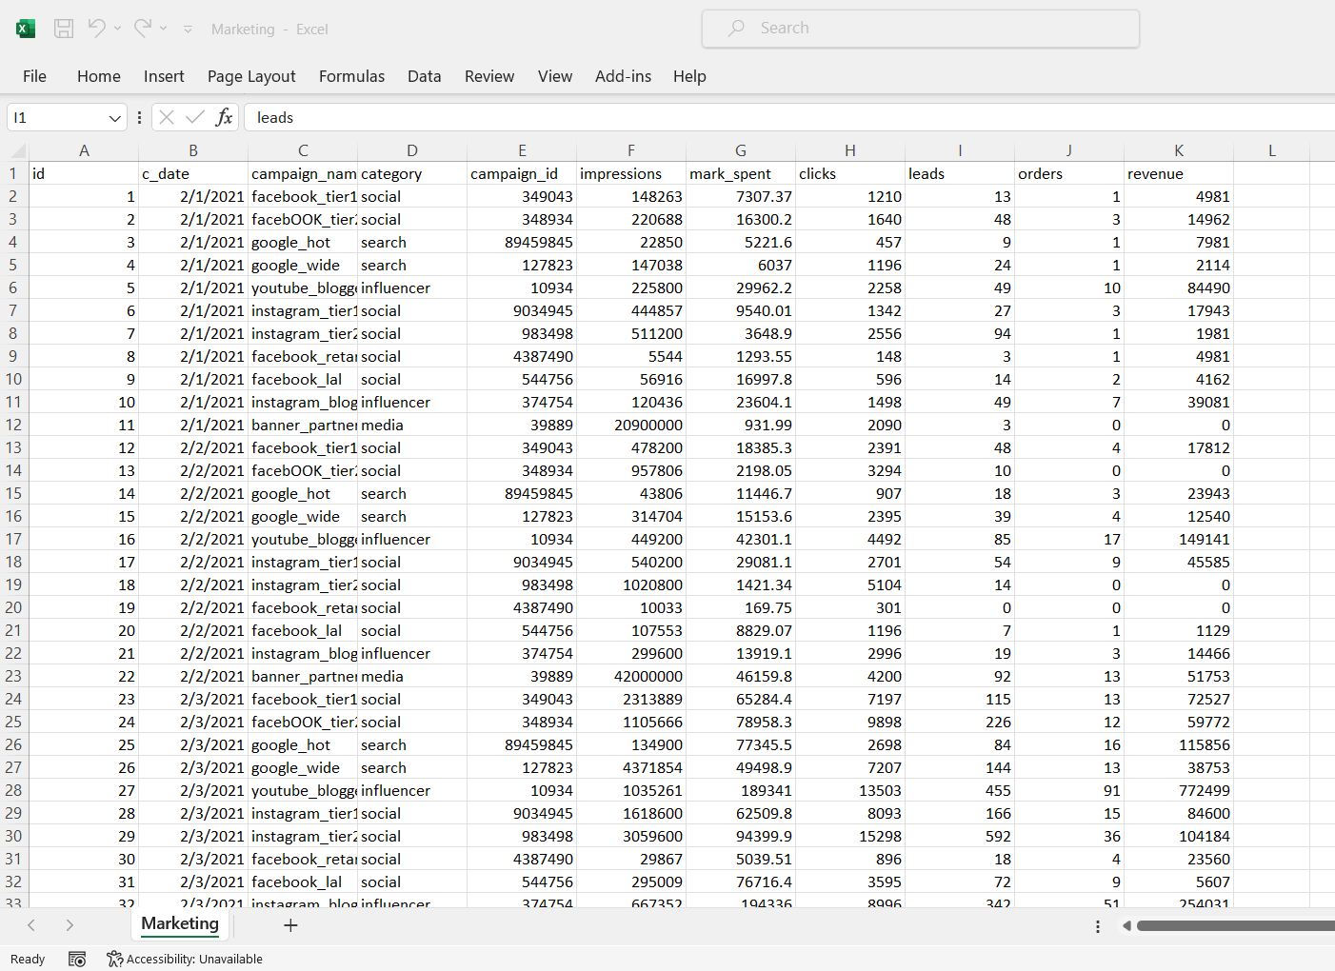

**Figure 3.1** **Dataset**

## **3.6 Dashboard Design**

In order to facilitate the comparative analysis between Tableau and PowerBI, specifically assessing their impact on marketing performance, there is a need to test each software and to do that a Dashboard will be designed. The design phase will involve developing dashboards on both platforms to visualise marketing data. Each dashboard will be designed to display key performance indicators (KPIs such as acquisition cost, ad spend, cost per clicks etc and other customer insights important for marketing decision-making. Also, emphasis will be given to leveraging the unique features of Tableau and PowerBI to enhance data visualisation and interactivity, aiming to provide actionable insights for optimising marketing strategies.

Testing these dashboards is important as it enables thorough evaluation of their usability and effectiveness in real-world marketing scenarios. Usability testing will gauge user experience, interaction fluidity, and overall satisfaction through structured surveys and qualitative feedback. Additionally, observational data during testing will capture user behaviours and preferences, providing more understanding of how each platform supports marketing performance objectives. This approach ensures comprehensive insights into the strengths and limitations of Tableau and PowerBI in enhancing marketing operations, guiding organisations in selecting the most suitable tool for their specific needs.

The figure below shows the initial step of Dashboard design on Tableau which involves Data loading, Chart Design and Dashboard Design

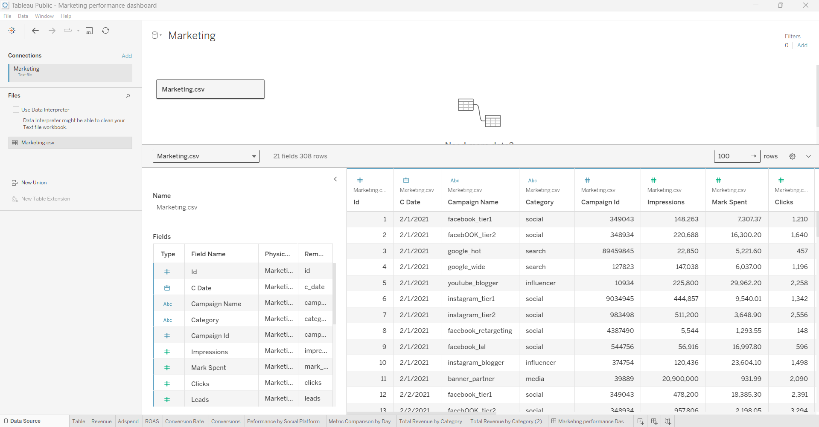

**Figure 3.2** **Data Source Interface**

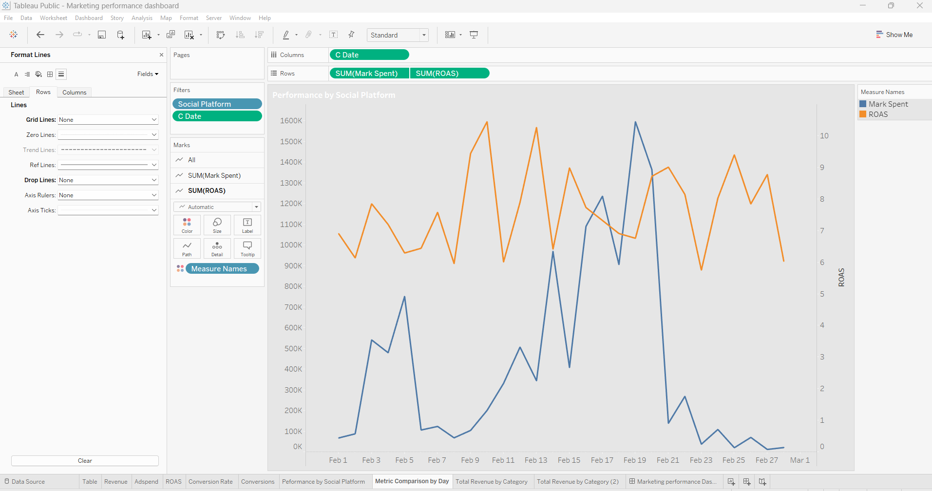

**Figure 3.3** **Line Chart - Data View**

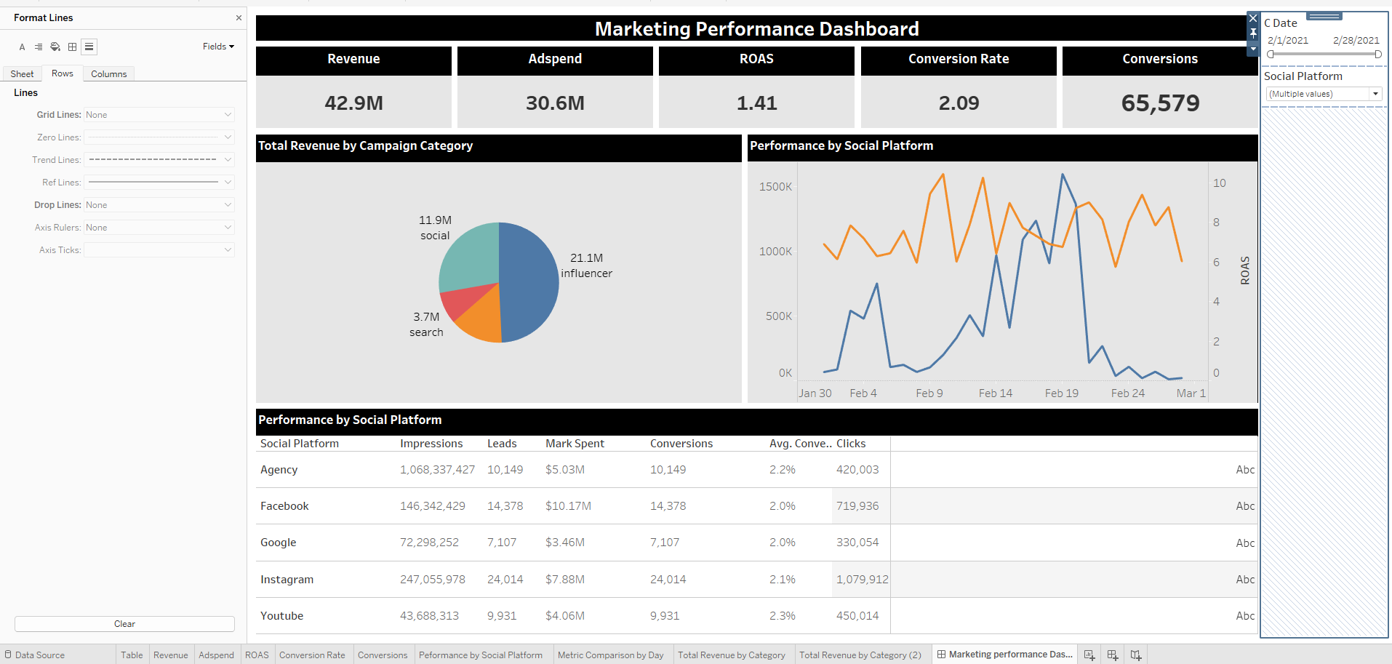

**Figure 3.4** **Dashboard View**

## **3.7 Data Collection**

The methods used in this study to collect the data are observation and questionnaire (survey). These methods will provide measurable information on the two softwares under study. A random sample of 30 data professionals will be recruited online through professional networks, such as LinkedIn, data science forums, and specialised marketing analytics communities. These participants are individuals with relevant experience in data visualisation and marketing analytics, ensuring that they can provide informed and valuable feedback on the dashboards. Prior to the study, participants will be debriefed via Zoom calls, where they will receive an overview of the research, instructions for the tasks, and the dashboard links.

The observation data will be collected by using a zoom screen recording feature as participants interact with a dashboard created on both Tableau and PowerBI. The use of zoom will allow the capture of information such as how users navigate the dashboard, how the users interact with the dashboard components and the difficulty in using the dashboard. The participants will perform specific tasks such as filter actions (action filters, date filters), zoom in/out, reading data, generating insights, and interpreting data. These tasks stimulate real-world usage of marketing dashboard. After completing the dashboard testing, participants will be administered a detailed questionnaire to provide feedback on their experiences. The questionnaire will include questions designed to measure various aspects of the software, such as ease of navigation, effectiveness of visualisations, interactivity, and overall satisfaction.

## **3.8 Feature Evaluation and Comparative Analysis**

In this section, the strengths and weaknesses of Tableau and PowerBI in relation to marketing performance will be analysed and evaluated. The analysis will involve evaluating each software responsiveness, loading speed, interactivity and usability where one platform may outperform the other. The analysis will focus on the features and function of both softwares and how it is used for marketing analytics. The data gathered post-development and testing will be stored in a google drive. To analyse the data, Microsoft Excel will be used. Descriptive statistical methods will be used. These methods are appropriate for summarising the data and providing a clear understanding of the impact and effectiveness of Tableau and PowerBI in marketing analytics. First, Frequency counts and percentages will be used to highlight the feedback of respondents on the software's interactivity capabilities, core features, and their experiences with the dashboards and reports. Mean statistics will be used to analyse the impact of each software on marketing performance. For example, the average rating given by participants for ease of navigation, effectiveness of visualisations, and overall satisfaction will be calculated to provide a quantitative measure of user experience.To measure the variability in responses, standard deviation will be calculated. This will help in understanding how consistent the feedback is across different participants.

## **4.0 Plan for Completion**

This section presents the plan for completion for this research. The plan includes timeline, tasks and experiments to be carried out. The period of the project is between May 1 to July 31. The table below shows the key steps and their expected duration.

|  |  |  |  |  |
| --- | --- | --- | --- | --- |
| **Step** | **Tasks** | **Start Date** | **End Date** | **Goal** |
| Research Planning | * Review Literatures * Formulate research objectives and questions * Develop methodology | May 10, 2024 | May 31, 2024 | Research questions, methodology developed |
| Documentation | * Fill Ethical Review * Fill Project Specification * Write Interim report | June 1, 2024 | June 24, 2024 | Ethical review Approved,  Project specification and Interim report completed |
| Dashboard Design | * Extract dataset * Develop Dashboard on PowerBI * Develop Dashboard on Tableau * Publish/Host Dashboard | June 10, 2024 | July 5, 2024 | Develop and Publish Dashboard |
| Data Collection | * Recruit participants * Conduct Dashboard Test * Conduct surveys | July 5, 2024 | July 10, 2024 | Data Collected |
| Data Analysis and Presentation | * Analyse and interpret data * Write report | July 10, 2024 | July 13, 2024 | Data Analysis and Report writing |
| Literature review and Writing | * Write Introduction, background * Write Literature review * Write methodology * Write Results and interpretation sections | June 10, 2024 | July 20, 2024 | First draft of Thesis completed |
| Review, Feedback and Revision | * Submit drafts for feedback * Rework drafts based on feedback | July 15, 2024 | July 20, 2024 | Feedback received and effected |
| Formatting and Proofread | * Edits documents * Editing and Formatting * Proofreading | July 20, 2024 | July 24, 2024 | Final Thesis document completed |
| Submission | * Submit thesis | July 25, 2024 | July 25, 2024 | Thesis submitted |
| PowerPoint Presentation | * Write PowerPoint presentation * Prepare for oral examination/demonstration | July 24, 2024 | July 30, 2024 | PowerPoint document completed |

**Table 4.1** **Plan for Completion key steps and their expected duration**

**Documentation**: The first step will involve putting all the project requisite documents in order, including a project plan, project specification, ethical review along with schedule and timeframe for the study.

**Dashboard Design**: In this step, I build the dashboards using Tableau and PowerBI to analyse and present marketing KPI. The data will visually represent important performance indicators (KPIs) and other important metrics.

**Data Collection:** This step is about collecting data from the participants. To do this, I will record the participants' interactions while using the dashboards built. The record will be done with the help of OBS Studio software and Google meet and after the session is over. Online surveys will be administered to get their feedback about the usability and efficiency of the dashboards.

**Data analysis and presentation**: Once all data is collected, descriptive statistical analysis will be used to analyse the data. The analysis includes mean and standard deviation, frequencies and percentages of respondents' feedback, which will be used to interpret the data as well as to understand the performance of designed dashboards. The results will be presented with the aid of tables and charts.

**Literature Review and Writing**: After the analysis and interpretation step, writing the literature review will follow. To contextualise and provide background to the research, previous study will be evaluated and additionally the research method, finding and discussion will be written

**Review, Feedback and Revision**: After the first draft, comes the editing stage, the document will be submitted to the supervisor for review. The feedback from the supervisors and peers will be applied to improve the quality and clarity of the paper.

**Formatting/Proofread**: This step ensures that the document adheres to required formatting guidelines and is free of grammatical errors.

**Submission**: Once the report is finalised, it will be submitted by the due date.

**PowerPoint Presentation**: PowerPoint presentation that summarises the method of research, findings and conclusions will be developed. This will help to present the research results to an audience  during a thesis defense or project presentation.

# **Reference**

Affonso, F. and Janiszewski, C. (2023). Marketing by design: the influence of perceptual structure on brand performance. Journal of Marketing, 87(5), 736-754.<https://doi.org/10.1177/00222429221142281>

Al-Kassab, J., Ouertani, Z. M., Schiuma, G., and Neely, A. (2014). "Information visualisation to support management decisions". International Journal of Information Technology and Decision Making, 13(02), 407-428.

American Marketing Association (2013). *Definition of Marketing.* https://www.ama.org/AboutAMA/Pages/Definition-of-Marketing.aspx

Anilkumar, K.J. and Akhade, K. (2024). A Review on Comparative Study of Popular Data Visualization Tools. ALOCHANA JOURNAL, 13(4), pp. 532-538. <https://alochana.org/wp-content/uploads/53-AJ2368.pdf>

Borkin, M., Vo, A., Bylinskii, Z., Isola, P., Sunkavalli, S., Oliva, A., and Pfister, H. (2013). What makes a visualization memorable?. Ieee Transactions on Visualization and Computer Graphics, 19(12), pp. 2306-2315.<https://doi.org/10.1109/tvcg.2013.234>

Borgman, C. (2012). The conundrum of sharing research data. Journal of the American Society for Information Science and Technology, 63(6), 1059-1078. <https://doi.org/10.1002/asi.22634>

Branda, A., Lala, V. and Gopalakrishna, P., (2018). The marketing analytics orientation (mao) of firms: identifying factors that create highly analytical marketing practices. *Journal of Marketing Analytics*, 6(3), pp.84-94. Available at:<https://doi.org/10.1057/s41270-018-0036-8>.

Cabanès, G. and Bennani, Y. (2011).  "Coupling clustering and visualization for knowledge discovery from data," The 2011 *International Joint Conference on Neural Networks*, San Jose, CA, USA, 2011, pp. 2127-2134, doi: 10.1109/IJCNN.2011.6033491.

Chavan, A. (2023). Data Visualization Tools Used for Decision Making: A Review. *International Research Journal of Modernization in Engineering Technology and Science*, 5(2), pp. 1338-1347. e-ISSN: 2582-5208. Available at: [www.irjmets.com](http://www.irjmets.com).

Cheng, O. and Lau, R., (2015). Big data stream analytics for near real-time sentiment analysis. *Journal of Computer and Communications*, 3(5), pp.189-195. <https://doi.org/10.4236/jcc.2015.35024>.

Choi, T., Wallace, S.W. and Wang, Y., (2018). Big Data Analytics in Operations Management. *Production and Operations Management*, 27(10), pp.1868-1883.<https://doi.org/10.1111/poms.12838>

[Chongwatpol, J.](https://www.emerald.com/insight/search?q=Jongsawas%20Chongwatpol) (2016), "Managing big data in coal-fired power plants: a business intelligence framework", [*Industrial Management & Data Systems*](https://www.emerald.com/insight/publication/issn/0263-5577), Vol. 116 (8), pp. 1779-1799. <https://doi.org/10.1108/IMDS-11-2015-0473>

Czinkota, M.R.,Kotabe, M., Vrontis, D. and Shams, S.M.R (2021). "[Direct Marketing, Sales Promotion, and Public Relations](https://ideas.repec.org/h/spr/sptchp/978-3-030-66916-4_13.html)," [Springer Texts in Business and Economics](https://ideas.repec.org/s/spr/sptchp.html), in: [Marketing Management](https://ideas.repec.org/b/spr/sptbec/978-3-030-66916-4.html), 13(4), pp. 607-647, Springer.

Datta, H., Ailawadi, K., and Heerde, H. (2017). How well does consumer-based brand equity align with sales-based brand equity and marketing-mix response?. Journal of Marketing, 81(3), 1-20.<https://doi.org/10.1509/jm.15.0340>

Davenport, T. (2006). Competing on Analytics. *Harvard business review.* 84.pp. 98-107. <https://www.strimgroup.com/wp-content/uploads/pdf/competing%20on%20analytics.pdf>

Den Hamer, P. (2005). The organization of Business Intelligence. The Hague: SDU Publishers.

Deo, A.A. & Sarode, P. (2024). Comparative Analysis of Data Visualization Tools: Tableau Vs. Power BI. Electronic International Interdisciplinary Research Journal, 13(2), pp. 1–4. DOI:<https://doi.org/10.5281/zenodo.10940214>.

Federer, L. and Joubert, D. (2018). Providing library support for interactive scientific and biomedical visualizations with tableau. Journal of Escience Librarianship, 7(1),pp. 1-10. e1120.<https://doi.org/10.7191/jeslib.2018.1120>

Fernández, A., Río, S. d., López, V., Bawakid, A., Jesus, M. J. d., Benítez, J. M., and Herrera, F. (2014). Big data with cloud computing: an insight on the computing environment, mapreduce, and programming frameworks. WIREs Data Mining and Knowledge Discovery, 4(5), 380-409. https://doi.org/10.1002/widm.1134

Few, S. (2012). "Show Me the Numbers: Designing Tables and Graphs to Enlighten". Analytics Press. 2. pp.1-373.

Friendly, M. (2009). Milestones in the history of thematic cartography, statistical graphics, and data visualization.

Gandomi, A., and Haider, M. (2015). "Beyond the hype: Big data concepts, methods, and analytics". International Journal of Information Management, 35(2), 137-144.

Grönroos, C. (2006). On defining marketing: finding a new roadmap for marketing. *Marketing Theory*, 6(4), 395-417. <https://doi.org/10.1177/1470593106069930> <https://www.researchgate.net/publication/215915802_On_defining_marketing_Finding_a_new_roadmap_for_marketing>

Gowthami, K. and Kumar, M.P., (2017). Study on business intelligence tools for enterprise dashboard development. *International Research Journal of Engineering and Technology,* 4(4), pp.2987-2992. <https://www.irjet.net/archives/V4/i4/IRJET-V4I4721.pdf>

Gundlach, G.T. and Wilkie, W.L. (2009) The American Marketing Association’s New Definition of Marketing: Perspective and Commentary on the 2007 Revision. *Journal of Public Policy & Marketing*. 28 (2), 259–264. <https://www3.nd.edu/~wwilkie/pdf/2009MKTGDefinationGundlachAndWilkieJPPM.pdf>

Hamad, F., Al-Aamr, R., Jabbar, S. A., and Fakhuri, H., 2021. Business intelligence in academic libraries in Jordan: Opportunities and challenges. IFLA Journal, 47(1), pp.37-50. Available at:<https://doi.org/10.1177/0340035220931882>.

Heer, J and Shneiderman, B. (2012). Interactive Dynamics for Visual Analysis. *Communications of the ACM*. 55 (4). Pp. 45-54. <https://idl.cs.washington.edu/files/2012-InteractiveDynamics-CACM.pdf>

Heinze, S., el Jundi, B., Berg, B. G., Homberg, U., Menzel, R., Pfeiffer, K., Hensgen, R., Zittrell, F., Dacke, M., Warrant, E., Pfuhl, G., Rybak, J., and Tedore, K. (2021). A unified platform to manage, share, and archive morphological and functional data in insect neuroscience. eLife, 10.pp. 1-25.  <https://doi.org/10.7554/eLife.65376>

Hunt, S. D. (2010), Marketing Theory: Foundations, Controversy, Strategy, ResourceAdvantage Theory. Armonk: M.E. Sharpe. Pp.3-470. <https://www2.ufjf.br/danilo_sampaio//files/2017/05/Shelby-D.-Hunt-Marketing-Theory_-Foundations-Controversy-Strategy-and-Resource-advantage-Theory-Routledge-2010.pdf>

Jena, B., 2019. An approach for forecast prediction in data analytics field by tableau software. *International Journal of Information Engineering and Electronic Business*, 11(1), pp.19-26. <https://doi.org/10.5815/ijieeb.2019.01.03>.

Kandel, S., Paepcke, A., Hellerstein, J., and Heer, J. (2012). Enterprise data analysis and visualization: an interview study. Ieee Transactions on Visualization and Computer Graphics, 18(12), 2917-2926.<https://doi.org/10.1109/tvcg.2012.219>

Keller, K. L. (2022). Understanding the changing role and functions of marketing. In L. R. Kahle, T. M. Lowrey, & J. Huber, *APA handbook of consumer psychology* (pp. 143–162). American Psychological Association. [https://doi.org/10.1037/0000262-005](https://psycnet.apa.org/doi/10.1037/0000262-005)

Kirk, A., (2012). Data Visualization: a successful design process. *Packt publishing LTD*

Kokina, J., Pachamanova, D. and Corbett, A. (2017). The role of data visualization and analytics in performance management: Guiding entrepreneurial growth decisions. Journal of Accounting Education, 38, pp.50-62. https://doi.org/10.1016/j.jaccedu.2016.12.005

Lavanya, A., Sindhuja, S., Lokhande, G., and Ali, W. (2023). A Comprehensive Review of Data Visualization Tools: Features, Strengths, and Weaknesses. *International Journal of Computer Engineering in Research Trends*, 10(1), pp. 10-20. <https://doi.org/10.22362/ijcert/2023/v10/i01/v10i0102>

Lehmann, D.R. (2004). Linking marketing to financial performance and firm value. *Journal of Marketing*, 68:73-75.

Li, Q. (2020). Overview of Data Visualization. Embodying Data.  *Shanghai Jiao Tong University Press.* 20. pp. 17–47. <https://www.ncbi.nlm.nih.gov/pmc/articles/PMC7303292/pdf/978-981-15-5069-0_Chapter_2.pdf>

[Lin, F.](https://www.emerald.com/insight/search?q=Fenfang%20Lin) and [Eng, T.-Y.](https://www.emerald.com/insight/search?q=Teck-Yong%20Eng) (2024), "Entrepreneurial performance and marketing analytics: the role of new product innovation", [*Journal of Small Business and Enterprise Development*](https://www.emerald.com/insight/publication/issn/1462-6004), 31(2), pp. 418-440. <https://doi.org/10.1108/JSBED-06-2023-0253>

Luca, D.L., Margiotta, C., Staatz, C., Garlow, E., Christensen, A. and Zivin, K., (2020). Financial toll of untreated perinatal mood and anxiety disorders among 2017 births in the United States. *American Journal of Public Health*, 110(6), pp.888-896. https://doi.org/10.2105/AJPH.2020.305619.

Lyer,A., Bali, S., Kumar, I., Churi, P., and Mistry, K. (2019). “Presentation Abstraction Control Architecture Pattern in Business Intelligence” In *International Conference on Advances in Computing and Data Sciences*. pp. 666-679. 10.1007/978-981-13-9942-8_62.

Mahajan, K. and Gokhale, L. (2017). Significance of digital data visualization tools in big data analysis for business decisions. *International Journal of Computer Applications*, 165(5), 15-18.<https://doi.org/10.5120/ijca2017913858>

 Manuri, F., Sanna, A., and Lamberti, F. (2019). Single view vs. multiple views scatterplots. International Journal of Electrical and Computer Engineering (Ijece), 9(2), 1426-1434.<https://doi.org/10.11591/ijece.v9i2.pp1426-1436>

[Mariani, M.](https://www.emerald.com/insight/search?q=Marcello%20Mariani), [Baggio, R.](https://www.emerald.com/insight/search?q=Rodolfo%20Baggio), [Fuchs, M.](https://www.emerald.com/insight/search?q=Matthias%20Fuchs) and [Höepken, W.](https://www.emerald.com/insight/search?q=Wolfram%20H%C3%B6epken) (2018), "Business intelligence and big data in hospitality and tourism: a systematic literature review", [*International Journal of Contemporary Hospitality Management*](https://www.emerald.com/insight/publication/issn/0959-6119), Vol. 30 No. 12, pp. 3514-3554. <https://doi.org/10.1108/IJCHM-07-2017-0461>

Mehanović, D. and Durmic, N. (2022). Case study application of business intelligence in digital advertising. *International Journal of E-Business Research,* 18(1), 1-16.<https://doi.org/10.4018/ijebr.293294>

Midway SR (2020);. Principles of Effective Data Visualization. *Patterns (N Y)*. 1(9):1-9. [https://www.cell.com/action/showPdf?pii=S2666-3899%2820%2930189-6](https://www.cell.com/action/showPdf?pii=S2666-3899(20)30189-6)

Miles, M. and Darroch, J. (2006). Large firms, entrepreneurial marketing processes, and the cycle of competitive advantage. *European Journal of Marketing*, 40(5/6), 485-501.<https://doi.org/10.1108/03090560610657804>

Nemkova, E., (2017). The impact of agility on the market performance of born-global firms: an exploratory study of the ‘tech city’ innovation cluster. *Journal of Business Research*, 80, pp.257-265. <https://doi.org/10.1016/j.jbusres.2017.04.017>.

Ngai, E.W.T., Gunasekaran, A., Wamba, S.F., Akter, S., Dubey, R. and Luo, C., 2017. Big data analytics in electronic markets. Electronic Markets, 27(2), pp.243-245. <https://doi.org/10.1007/s12525-017-0261-6>

Nofal, M., and Yusof, Z. (2013). Integration of Business Intelligence and Enterprise Resource Planning within Organizations. Technology, 11, pp. 658-665.

Ozdemir, M., Ülkü, E. E., and Yıldız, K. (2023). Analysis and Comparison of Business Intelligence Tools Most Preferred by Companies in Turkey. *Balkan Journal of Electrical and Computer Engineering*, 11(2), 144-155. <https://doi.org/10.17694/bajece.1123171>

Pavithra. J. (2012). A Study on Distribution Channels in CementIndustry. International Journal of Innovative Research in Science, Engineering and Technology,  1 (2). 192-199. <https://www.ijirset.com/upload/december/9_A%20STUDY.pdf>

Piin, L and Nagalingham, S., (2023). Visualization of Business Intelligence Insights into Aviation Accidents. *International Journal of Advanced Computer Science and Applications (IJACSA)*, 14(1), pp.857-875. http://dx.doi.org/10.14569/IJACSA.2023.0140194

Pirttimäki, V. and Hannula, M., (2003). Process Models of Business Intelligence. In: Frontiers of e-Business Research, Conference Proceedings, Tampere, Cityoffset Oy, pp. 250-260.

Post, F. H., Nielson, G. M., and Bonneau, G. P. (2003). Data visualization: The state of the art. Dordrecht: *Kluwer Academic Publishers*

Raisinghani, M. (2004). Business Intelligence in the Digital Economy: Opportunities, Limitations and Risks. *IDEA Group Publishing*,pp.1-269. [10.4018/978-1-59140-206-0](https://doi.org/10.4018/978-1-59140-206-0)

Rasmey, H., and Raghul, M.(2017). Literature Review of Business Intelligence. *School of Business and Engineering Halmstad University*, Sweden.<http://www.diva-portal.org/smash/get/diva2:1080911/FULLTEXT01.pdf>

Reuter, L. H., Tukey, P., Maloney, L. T., Pani, J. R., and Smith, S. (1990). Human perception and visualization. In Proceedings of the 1st Conference on Visualization’90*. IEEE Computer Society Press.* pp. 401–406.

Ribeiro, R.B. and Soares, I., (2015). Marketing/marketing science. The Wiley Blackwell encyclopedia of consumption and consumer studies, pp.1-5.

Ringel, D. and Skiera, B. (2016). Visualizing asymmetric competition among more than 1,000 products using big search data. Marketing Science, 35(3), 511-534. <https://doi.org/10.1287/mksc.2015.0950>

Savoska, S. and Bocevska, A. (2016). Data visualization in business intelligent &amp;analysis – analysis of first positioned tools according to gartner’s magic quadrant in ability to execute.pp. 236-243.<https://www.academia.edu/80888176/Data_Visualization_in_Business_Intelligent_and_Analysis_Analysis_of_First_Positioned_Tools_According_to_Gartner_s_Magic_Quadrant_in_Ability_to_Execute>

Sheth, J. and Uslay, C. (2007). Implications of the revised definition of marketing: from exchange to value creation. *Journal of Public Policy & Marketing*, 26(2), 302-307. <https://doi.org/10.1509/jppm.26.2.302>

Skender, F., and Manevska, V. (2022). Data Visualization Tools - Preview and Comparison. Journal of Emerging Computer Technologies, 2(1), 30-35. <https://dergipark.org.tr/en/download/article-file/2503669>

Søilen, K. S (2015). A place for Intelligence studies as a Scientific Discipline, Halmstad, Sweden. Journal of Intelligence Studies in Business, Vol. 5(3), pp. 35-46. [10.37380/jisib.v5i3.136](http://dx.doi.org/10.37380/jisib.v5i3.136)

Spence, R. (2007). Information visualization: Design for interaction (2nd ed.). Harlow: *Pearson/Prentice Hall.*

Srivastava, D. (2023). "An Introduction to Data Visualization Tools and Techniques in Various Domains," International Journal of Computer Trends and Technology, 71,(4), pp. 125-130. <https://ijcttjournal.org/2023/Volume-71%20Issue-4/IJCTT-V71I4P116.pdf>

 Tambunan, E., Khaswarina, S., & Kusumawaty, Y. (2022). The effect of market strategy on marketing performance of smallholder rubber farmers in central kuantan district, kuantan singingi regency. *Agricultural Social Economic Journal,* 22(1), 23-28. <https://doi.org/10.21776/ub.agrise.2022.022.1.4>

Tang, N., Wu, E., & Li, G. (2019). Towards Democratizing Relational Data Visualization. Proceedings of the 2019 International Conference on Management of Data. pp. 2025-2030. <https://dl.acm.org/doi/pdf/10.1145/3299869.3314029>

Todorovic, D. (2008) Gestalt principles. Scholarpedia, 3(12):5345. [10.4249/scholarpedia.5345](http://dx.doi.org/10.4249/scholarpedia.5345)

Tufte, E. (2001). The visual display of quantitative information. Cheshire, CT: *Graphics Press.* Pp.13-191. <https://faculty.salisbury.edu/~jtanderson/teaching/cosc311/fa21/files/tufte.pdf>

Urpa, L. M. and Anders, S. (2019). Focused multidimensional scaling: interactive visualization for exploration of high-dimensional data. BMC Bioinformatics, 20(1),pp221-228<https://doi.org/10.1186/s12859-019-2780-y>

Vercellis, C. (2009). Business Intelligence: Data Mining and Optimization for Decision Making.pp 1-420 10.1002/9780470753866. <https://repository.dinus.ac.id/docs/ajar/Vercellis_-_Business_Intelligence_-_2009.pdf>

Vine, D.M. (2000). Internet Business Intelligence: How to Build a Big Company System on a Small Company Budget.Information Today, Inc.pp1-423. <https://books.google.com.ng/books?id=wroH_q74HaMC&printsec=frontcover#v=onepage&q&f=false>

Ware, C. (2012). Information visualization: Perception for design. Burlington: *Elsevier Science*. Pp, 1-27. <https://www.ifs.tuwien.ac.at/~silvia/wien/vu-infovis/articles/book_information-visualization-perception-for-design_Ware_Chapter1.pdf>

Wixom, B. and Watson, H. (2010). The BI-Based Organization. *International Journal of Business Intelligence Research*, 1(1), pp. 12-24. [10.4018/jbir.2010071702](http://dx.doi.org/10.4018/jbir.2010071702)

Wolfgang M, and Schumann,H. (2003), "Visualization for Modeling and Simulation: Visualization Methods for Time-Dependent Data-An Overview,” Proceedings of the 35th Conference on Winter Simulation: Driving Innovation,1. pp. 737–745. <https://citeseerx.ist.psu.edu/document?repid=rep1&type=pdf&doi=e63b349c3ea4bad3cb7ad3d560502d3bcb3cc755>

Yarmuluk, D. (2019). Discover the 4 key traits of a great data visualization. Retrieved from Microsoft Website

Xu, A. (2024). Marketing decision model and consumer behavior prediction with deep learning. Journal of Organizational and End User Computing, 36(1), 1-25.<https://doi.org/10.4018/joeuc.336547>

Vynohradova, O. (2021). Organization of advertising activities at production enterprises. Economy Management Business, (1). https://doi.org/10.31673/2415-8089.2021.011015